Trump on Brexit: America is next

By [Stephen Collinson](https://us.cnn.com/profiles/stephen-collinson), CNN

Updated 4:46 AM ET, Sat June 25, 2016

**Washington (CNN)**British voters just shattered political convention in a stunning repudiation of the ruling establishment. Donald Trump is betting America is about to do the same.

Voters in the UK did more than reject the European Union and topple their pro-EU Prime Minister David Cameron in a referendum Thursday.

They also set off a cascade of events that could spark global economic chaos, remake the Western world, reverberate through November's presidential election and challenge U.S. security for years to come.

The referendum campaign -- just like the U.S. election -- has boiled with populist anger, fear-mongering by politicians, hostility towards distant political elites and resurgent nationalism, and exposed a visceral feeling in the electorate that ordinary voters have lost control of the politics that shape their own lives. Its success raises the question of whether those forces will exert a similar influence in America in November.

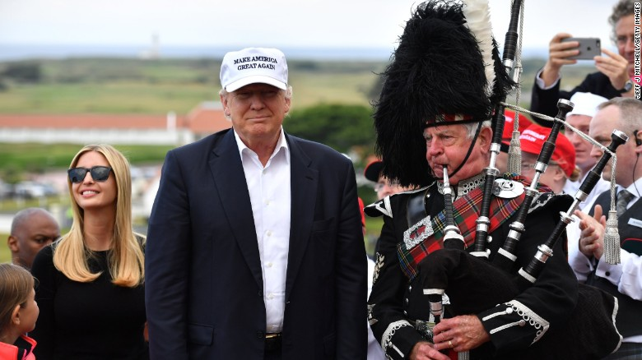

The presumptive Republican presidential nominee, who arrived in the UK to visit his Scottish golf courses just as the referendum result was announced, declared Friday that the U.S. is next.

"Come November, the American people will have the chance to re-declare their independence. Americans will have a chance to vote for trade, immigration and foreign policies that put our citizens first," he said. "They will have the chance to reject today's rule by the global elite, and to embrace real change that delivers a government of, by and for the people."

Indeed, British voters delivered the kind of crushing rejection of the political, business and media elites that Trump has been railing against.

The Brits also snubbed President Barack Obama's warnings against voting to leave Europe and risked triggering a global recession that would weaken already sluggish U.S. economic growth and dampen the hopes of his chosen successor, Hillary Clinton.

In her first reaction to the news from Britain, Clinton immediately took a swipe at Trump, though not by name. She called for Americans to respond to the vote by pulling together "to solve our challenges as a country, not tear each other down."

Clinton also noted the global economic risks of the UK referendum, saying in a statement: "Our first task has to be to make sure that the economic uncertainty created by these events does not hurt working families here in America."

In a particularly striking development, UK voters completely disregarded warnings from elite voices of the consequences of tearing the political system that has largely delivered peace and prosperity since World War II.

Similar warnings have been heard in the U.S. election -- especially from Clinton and establishment politicians who fear Trump's "America First" stance would send shockwaves through the global system and see America pull back from its role as a guarantor of Western security.

But in the UK this week, outsider politicians seem to have carried just as much weight with many British voters as more conventional fact-based arguments. World authorities like the IMF for example warned about the consequences of a Brexit -- but voters went ahead and voted to leave anyway.

Speaking to CNN, former British Prime Minister Tony Blair described the Brexit result as a "big experiment in insurgent politics."

He said the centre-left and centre-right needed to "rediscover radical, powerful answers in a climate driven by anger ... a revolt against what is seen as established wisdom, but what is actually people making difficult decisions in difficult circumstances."

There are, of course, several key differences between the British referendum and America's looming election.

The UK vote was mostly about delivering a stunning and final blow to the country's long and reluctant marriage with Europe and turned on a host of local factors including extreme Euro-skepticism within the governing Conservative Party, distrust of European politicians and institutions and disenchantment with Britain's reduced place in the world.

But in a larger symbolic sense, the referendum result, narrow as it was -- 52% to 48% -- demonstrated the potential of voters to wield a stunning shock to the political system that can shatter the logic and assumptions of conventional politics.

There's no guarantee that American voters will show the same kind of rebelliousness and willingness to leap into the unknown in November as a slim majority of Britons did on Thursday. And the U.S. system of state-by-state races and an electoral college could mitigate against some of the grassroots anger that exploded in a binary "Leave" or "Remain" vote in Britain.

But events in Europe must trigger at least some concern among Democrats.

Pollsters in the UK underestimated the fury of grassroots voters outside metropolitan areas in a way that could be mirrored in the United States, where Clinton now enjoys a lead in national surveys.

Furthermore, "Brexit" forces triumphed partly because the Labour Party could not deliver its traditional working class voters in some big post-industrial cities for the "Remain" campaign, despite the support of party leaders.

It is not a stretch to wonder whether the kind of political message that was so powerful in the referendum -- featuring a harsh critique of free trade and a demands to "take our country back" -- could prove just as effective among blue-collar workers in rust belt states in the United States.

Certainly, it's a message that Trump has been hammering with success all election season and is at the center of his claims to be able to remake the U.S. electoral map. And the billionaire has consistently bested Clinton when voters are asked who is best equipped to handle the economy.

The immediate stock market contagion unleashed by the referendum across the globe represented the worst equity carnage since the start of the Great Recession in 2008.

If the losses prove short-lived, the impact of the referendum on the U.S. economy and politics could be temporary.

But if "Brexit" ushers in a period of economic volatility across Europe that begins to squelch growth, the U.S. economy could be badly affected -- complicating Clinton's bid to pull off the tough assignment of winning a third consecutive White House term for the Democrats.

Trump would meanwhile seize on any slowdown in the U.S. precipitated by Brexit to argue that Obama's economic management is a failure and it is time to try something new.

But there are also warning signs for Trump.

Though he was quick to claim a share of the credit for the British political earthquake -- placing it in the context of a revolt against global elites in which he sees himself as a major player -- a prolonged period of world turmoil could also work against the billionaire former reality star.

Such an environment could bolster Clinton's claims that a crisis is no time to choose a president who has no experience of governing and that her pedigree as a former secretary of state and relationships with leaders all over the world are a perfect fit for a perilous moment.

The Democratic presumptive nominee made that argument in her statement: "This time of uncertainty only underscores the need for calm, steady, experienced leadership in the White House to protect Americans' pocketbooks and livelihoods, to support our friends and allies, to stand up to our adversaries, and to defend our interests."

Her campaign later issued a fundraising appeal with that message, writing, "No matter what the collective wisdom of our political punditry has to say between now and November, Donald Trump has a real chance of winning this election."

Clinton's campaign worked hard to demonstrate a contrast between Clinton and Trump as potential leaders in a time of crisis. The Clinton camp also sought to downplay similarities between the seething political scenes in the U.K. and the United States.

"It is important that we recognize that this American election is about what is happening here in America not what is happening in Yorkshire or in Cardiff," said Clinton's senior adviser Jake Sullivan on a conference call.

Sullivan also rejected the idea that Clinton could find herself overtaken by a similar populist tide in November, saying she had spent months on the campaign trail and was intimately familiar with the difficulties facing many working Americans.

The possible economic consequences of Brexit in the short-term could be dwarfed by the geopolitical shakeup that is now looming in the years to come.

Britain's referendum has already set off calls in Europe for similar separation votes in other Eurosceptic nations, threatening to dismantle the economic and political union that has been a pillar of transatlantic stability for 70 years and been a crucial partner for the United States.

As the U.S. faces challenges to its power in Asia from a rising China and in Europe from a recalcitrant Russia and in the Middle East from a motley group of insurgent forces, Washington can hardly afford the splintering of its co-guarantor of Western security.

In addition, the referendum looks likely to result in the fracturing of America's closest historic ally, the United Kingdom -- a factor that could be a diplomatic nightmare for the next president.

In the hours after the vote, [Scotland's First Minister Nicola Sturgeon announced plans to draft new legislation](http://www.cnn.com/2016/06/24/europe/scotland-eu-referendum/index.html) to allow a second independence referendum north of the border after pro-EU Scots narrowly voted to stay in the United Kingdom in 2014.

Though a Scottish referendum may not take place for years, it will revive questions about a neutering of British military power and the fate of Britain's Scotland-based nuclear deterrent -- which nationalists opposed and is part of NATO's security infrastructure -- that the next U.S. president will be forced to grapple with.